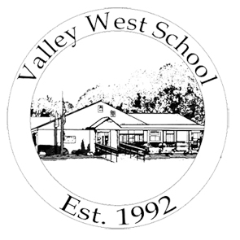
VALLEY WEST SCHOOL
269 Moore Street, Chicopee, MA 01013
(413) 592-6069
www.valleywestschool.com

PARENT ADVISORY GROUP

The Parent Advisory Group shall advise the school on matters that pertain to the education, health, and safety of the students in the program. Valley West School will provide the meeting space.

All meetings to take place at: Valley West School
269 Moore Street
Chicopee, MA 01013

If you are planning on attending a meeting please contact the school at
413-592-6069 so we can ensure for adequate meeting space.

Meetings are to take place on the following dates:

October 6th ……….. 9:00 AM
January 12th ……….9:00 AM
March 23rd ...............9:00 AM
May 25th……………..9:00 AM

Summer School Meeting:
July 13th………….9:00 AM

